Ryan Sleeper

SWDV 665

Week 2

Screenshots of Grocery App

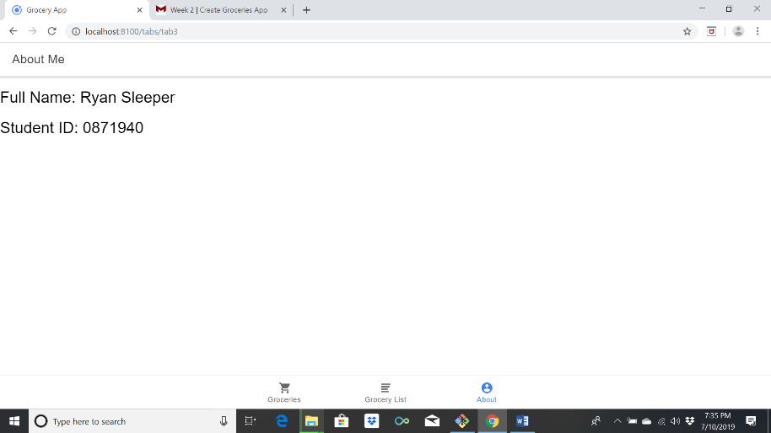

1. This is the “About” tab. It contains my full name and student ID.

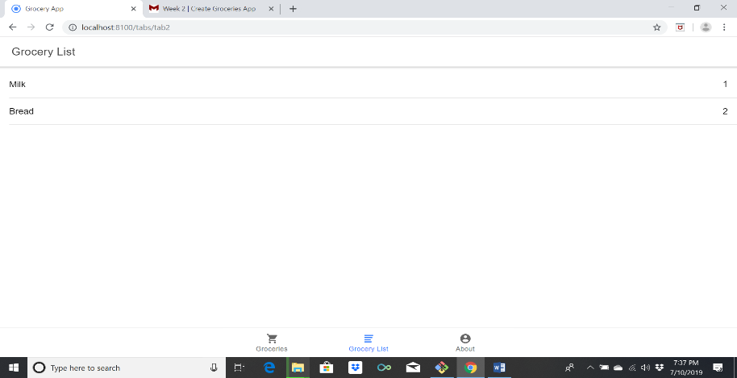

2. This is my “Grocery List” tab. It contains the items that I added to the grocery list, along with the sliding feature.

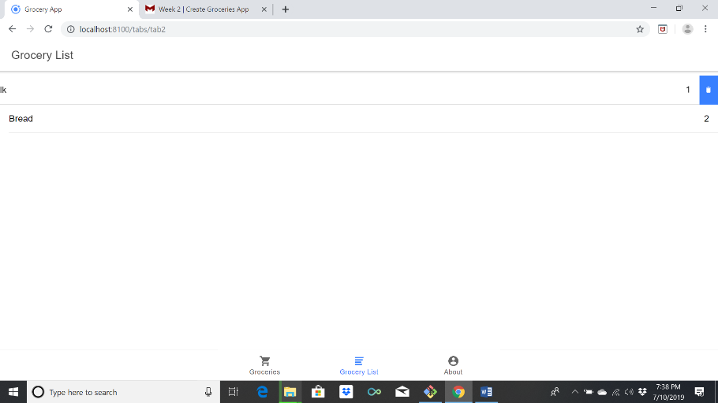

3. This is my first tab. It automatically created this page with helpful links, so I did not want to delete them if I didn’t have to because the links provided a lot of useful information.

